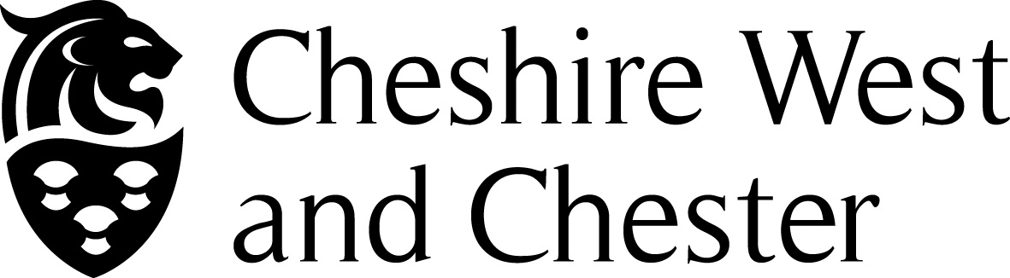

INSTRUMENT OF GOVERNMENT

1. The name of the school is Winsford High Street Community Primary School

2. The school is a community school.

- The name of the governing body is “ The governing body of Winsford High Street Community Primary School“

4. The governing body shall consist of:

(a) 2 parent governors;

(b) 1 LA governor;

(c) 1 staff governor;

(d) 1 Headteacher

(e) 7 co-opted governors

- Total number of governors 12

6 This instrument of government comes into effect on 28 April 2014

7 This instrument was made by order of the Cheshire West and Chester Council on 28 April 2014

8 A copy of the instrument must be supplied to every member of the governor
body ( and the Headteacher if not a governor )

